Creating launch template for creating auto scaling group

Created autoscaling group

Instance has launched as per the desired value

Launching apache2 service on the instance

As per the CPU utilization based cloudwatch has created for both scnerios

CPU utilization>80 : 2 capacity units added

CPU utilization<60: Remove 1 capacity units

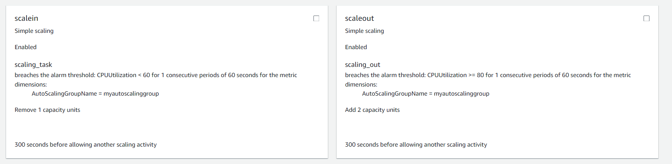

Creating load target group, using this creating load balancer

Attaching the application load balancer to the auto scaling group

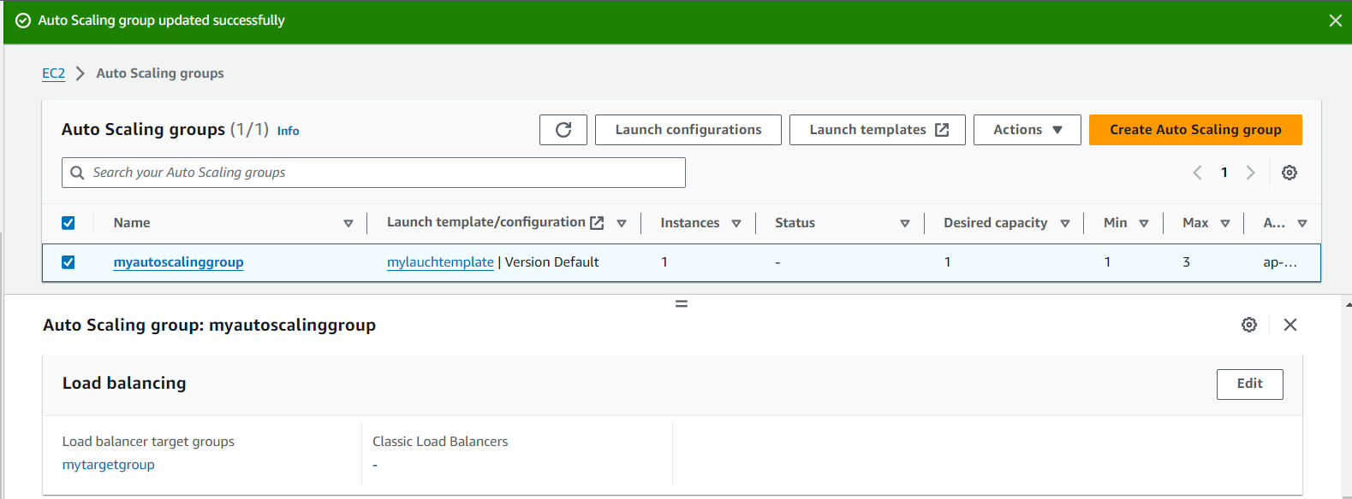

Route53

Note: Domain registration is paid so given the steps below that how it is processing

Creating a hosted zone using abc.cf

Creating a record to route the traffic to the load balancer

Load balancer route the traffic to the load that is auto scaling group consist of the servers

As per the load increases which is equally distributed by the load balancer and if it is increased or decreased which will effect the CPU utilization and as per the configuration it will add or remove the instances by the auto scaling group